August 15, 2021

Interstate 11 Tier 1 EIS Study Team
c/o ADOT Communications
1655 W. Jackson St., MD 126F
Phoenix, AZ 85007

RE: Comments on the Final Tier 1 Environmental Impact Statement and Preliminary Section 4(f) Evaluation and associated materials: Impacts on Pima County, Arizona.

I-11 Corridor Study Team,

On behalf of the Tucson Historic Preservation Foundation (THPF) and our thousands of members and supporters in Southern Arizona, we wish to provide additional comments on the Final Tier 1 Environmental Impact Statement and Preliminary Section 4(f) Evaluation and associated materials in addition to the letter submitted by Coalition for Sonoran Desert Protection (CSDP) signed on to by THPF.

The Preferred Alternative Options identified in the Corridor Study, if executed without significant mitigation, would have devastating and consequential adverse effects on the heritage areas of underrepresented populations. As noted in the CSDP letter, the Western Alternative through Pima County is routed through traditional Tohono O’odham lands where there is a large population of O’odham tribal members, countless cultural resources and sacred landscapes, and our organization finds this routing option is unacceptable.

Portions of the Eastern Alternative are routed through historically Mexican American, minority-majority and low income urban neighborhoods, including Barrio Anita, Barrio Membrillo, and South Tucson, many of which are listed in the National Register of Historic Places, as well as the pending National Historic Landmark district Los Barrios Viejos.
Our additional comments in this letter focus on the Eastern Alternative, which, if improperly pursued, could negatively and adversely impact minority populations, historic districts and irreplaceable cultural resources in Tucson and South Tucson.

Any design that expands the current I-10 alignment upwards or outwards through Tucson and South Tucson are unacceptable. We believe colocation is the preferred option only when I-10/I-11 is placed underground through central Tucson, from Grant Road through Park Avenue. Alternatives for colocation - adding an upper deck to the existing freeway or expanding the existing right of way through the use of the present access roads - are unacceptable. The negative impact and extreme adverse effect on historic resources and minority neighborhoods would be enormous and destroy communities in perpetuity.

This underground mitigation would maintain essential connectivity with the business hub of the city while avoiding damage to the sensitive desert communities of the Avra Valley. The underground alignment would mitigate the enormous existing urban heat island caused by the current freeway infrastructure and would offer reparation for the injustices inflicted on Tucson’s Mexican American neighborhoods by the original construction of I-10. In President Biden’s words, it would serve to “reconnect neighborhoods cut off by historic investments.” Engineering examples can be found in most major cities today including Phoenix, Portland, Seattle and Boston.

We formally request the collocation option but only with undergrounding as described above. This mitigation would support the economic/transportation needs of Tucson, alleviate the environmental impact of both proposed alternative routes, protect the extraordinary heritage of our historic city, and provide reparation for the historic injustice rendered by Federal development projects of the past.

Thank you for considering our comments. As always, we appreciate the time you have put into this effort.

Sincerely,

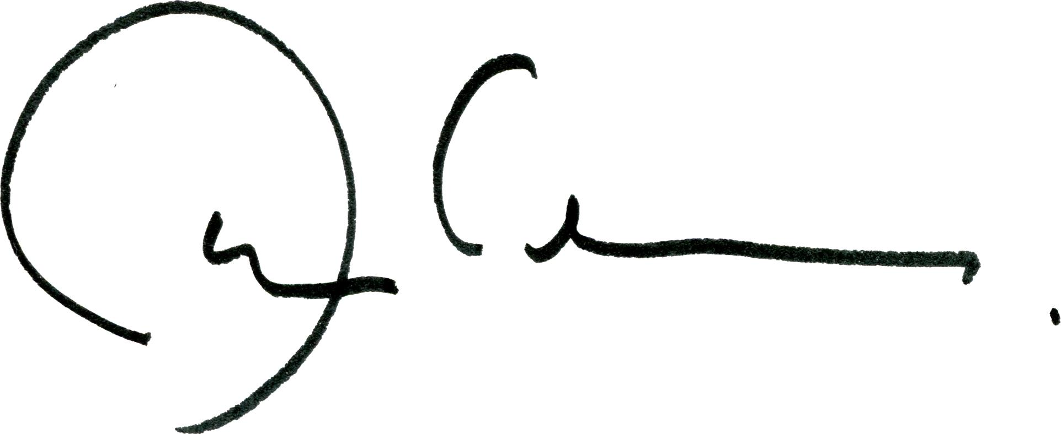

Demion Clinco, CEO
Tucson Historic Preservation Foundation
PO Box 40008
Tucson, Arizona 85717

CC:
Hon. Senator Kyrsten Sinema
Hon. Senator Mark Kelly
Hon. Representative Ann Kirkpatrick
Hon. Representative Raúl Grijalva
Hon. Tucson Mayor Regina Romero and City Council
Hon. Pima County Board of Supervisors
Kathryn Leonard, Arizona State Historic Preservation Officer
John S. Halikowski, Director, Arizona Department of Transportation

